

**Tecnológico de Monterrey**

**TC2037: Implementación de métodos computacionales**

Actividad 1.1: Practicando las matemáticas básicas

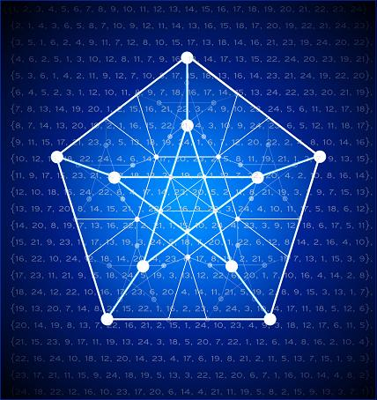

* Carlos Estrada Ceballos A01638214
* Natalia Velasco García A01638047
* Abigail Velasco García A01638095

**Herramientas básicas**

Herramientas básicas Fuente: J.E. Hopcroft, J.D. Ullman. Introduction to Automata Theory, Languages, and Computation. Addison‐Wesley, (1979), pp. 10‐11.

**1.1 In the tree of Fig 1.4,**

1. **Which vertices are leaves and which are interior vertices?**

Hojas: 2,4,9,8,6

Vértices interiores: 1, 3, 5, 7

1. **Which vertices are the sons of 5?**

Hijos: 7,8

1. **Which vertex is the father of 5?**

Padre: 3

1. **What is the length of the path from 1 to 9?**

Longitud: 5

1. **Which vertex is the root?**

Raíz: 1

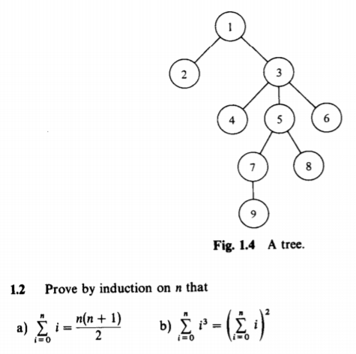

**1.2 Prove by induction on n that**

$$i\left(1\right)= \frac{1\left(1+1\right)}{2}$$ $$i\left(1\right)= \frac{2}{2}=1$$ $$i\left(n+1\right)=1+2+3+…+n+(n+1)$$ $$i\left(n+1\right)= \frac{n(n+1)}{2}+n+1$$ $$i\left(n+1\right)= \frac{n(n+1)}{2}+\frac{2(n+1)}{2}$$ $$i\left(n+1\right)= \frac{(n+1)(n+2)}{2}$$ $$i\left(n+1\right)= \frac{(n+1)(\left(n+1\right)+1)}{2}$$